**JOB RECRUITMENT & HIRING MANAGEMENT SYSTEM**

**NAME: KOLLI JAGAN MOHAN RAO**

**Phase 2: Org Setup & Configuration**

* **Salesforce Editions**: We used the **Developer Edition** as our free, all-in-one environment for building and testing.

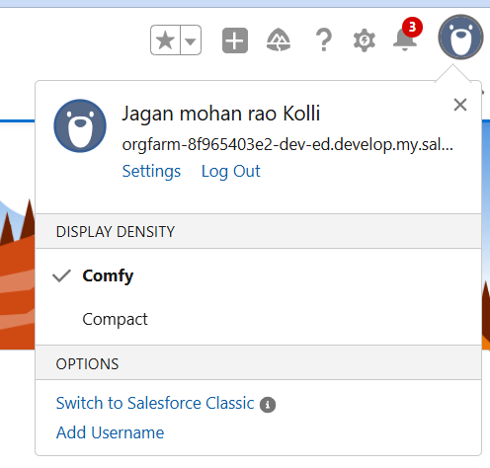

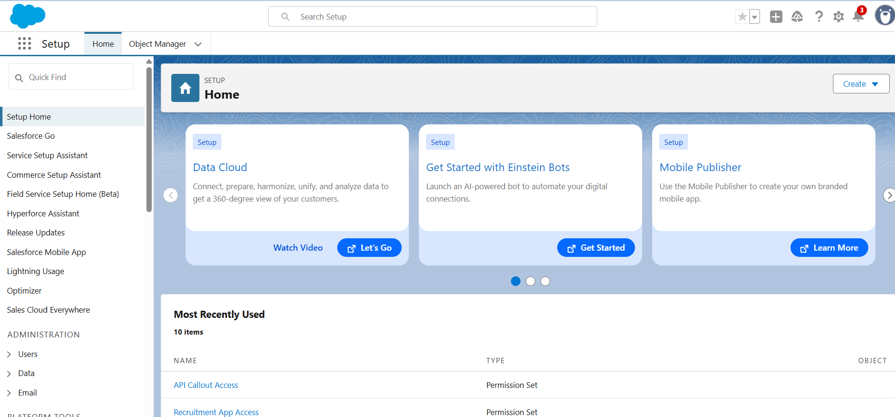

* **Company Profile Setup**: We configured the basic company settings, including the default **time zone** and **currency**.
* **Business Hours & Holidays**: These were acknowledged as important for future calculations but were **not configured** as part of this project's scope.
* **Fiscal Year Settings**: We kept the **Standard Fiscal Year** (January - December) as the org's default.
* **User Setup & Licenses**: We created two test users (Priya and Raj) and assigned them the **Salesforce** license.

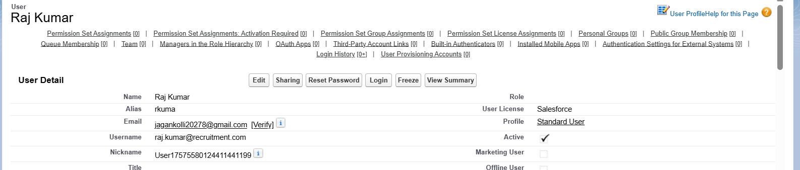

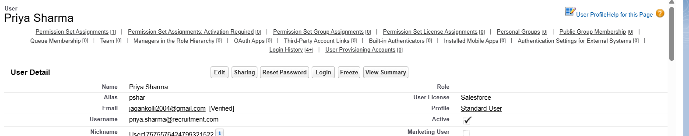

* **Profiles**: We cloned the **Standard User** profile to create a new custom **"Recruiter"** profile. We then assigned this new profile to our test user.
* **Roles**: A role hierarchy was **not built out**; we relied on ownership and profile settings for security.
* **Permission Sets**: We created two key Permission Sets:
  1. **API Callout Access**: To grant the system permissions needed to make the API callout.
  2. **Recruitment App Access**: To grant visibility to our custom tabs and objects, bypassing issues with the standard profile editor.

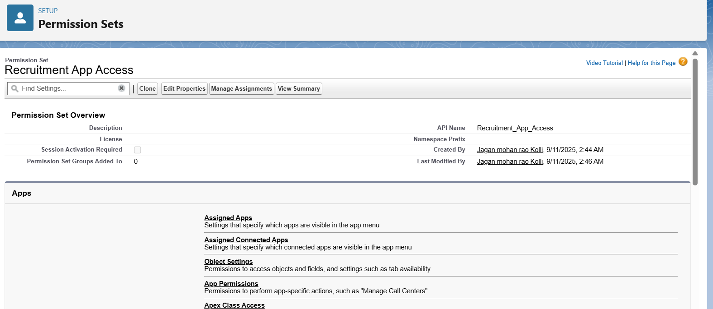

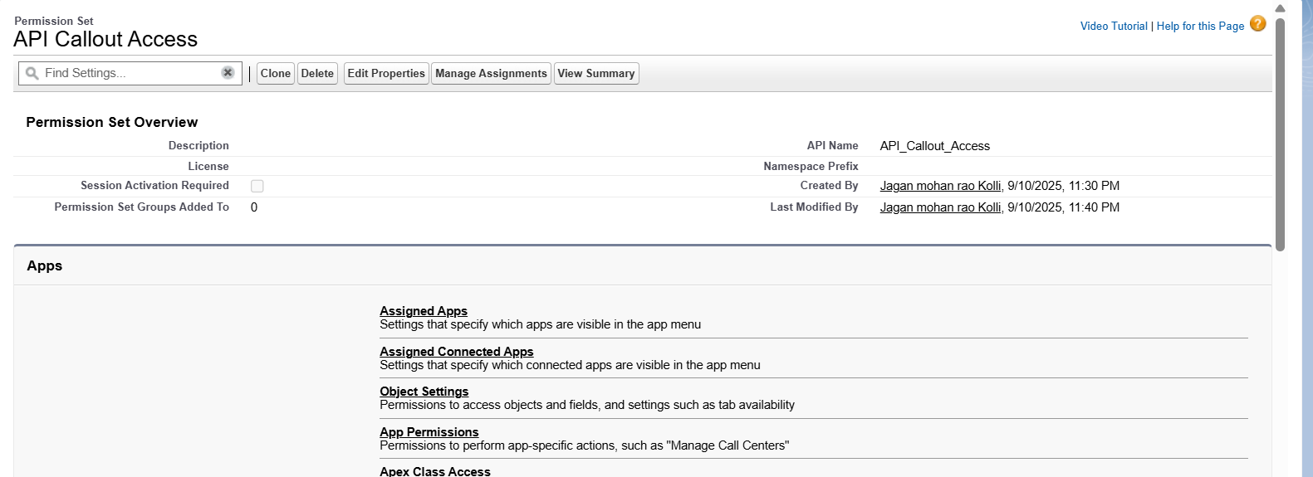

* **OWD**: We set the Organization-Wide Defaults for our custom Job__c and Candidate__c objects to **Private**.
* **Deployment Basics**: We learned the deployment process using **SFDX** in Phase 8, where we retrieved and deployed project components using a package.xml manifest.